**cal command:-**

If you want to display the calendar, we need to use cal command. By default, it will display the current month as shown in the below screenshot.

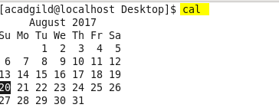

If you want to any display any month of any year, you need to give in below format.

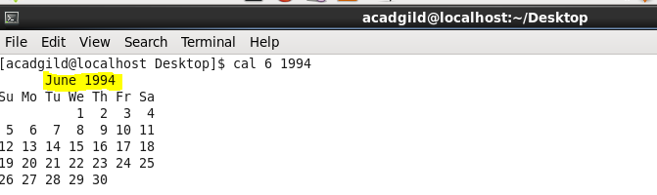

Here moth is 6, that is june and year is 1994. So, we have displayed 6th month of 1994.